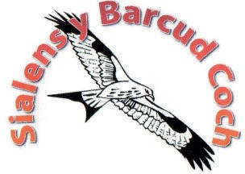
Sialens Y Barcud Coch
Red Kite Challenge
27/04/2024
Ffurflen Noddi/Sponsorship Form
Apel Uned Cemotherapi Bronglais Chemotherapy Unit Appeal/
Ward Strôc Ystwyth
End/Name:-
Cyfeiriad/Address:-
Rhif ffôn/Phone Number:-
Cyfeiriad E-bost/Email Address:-
Mynediad am ddim os codwch £50.00! Free Entry if you raise £50.00!
Dewch â'r ffurflen yma a'r swm a gasglwyd gyda chi i ganolfan y ras pan fyddwch yn casglu eich rhif ar ddiwrnod y ras er mwyn cael rhedeg am ddim! Gwnewch unrhyw sieciau'n daladwy i Apêl Uned Cemotherapi Bronglais neu Ward Strôc Ystwyth.
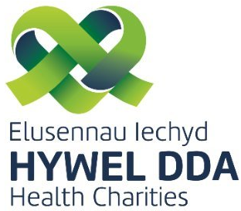
Bring this form and the sum collected with you to the race HQ when you pick up your number on race day for your entry fee to be reimbursed! Please make any cheques payable to the either Bronglais Chemotherapy Unit Appeal or Ystwyth Stroke Ward.

Enw/Name | Rhif Cyswllt/  Contact Number | Swm rhodd/ Donation Amount | Wedi derbyn/ Received?
Enw/Name | Rhif Cyswllt/  Contact Number | Swm rhodd/ Donation Amount | Wedi derbyn/ Received?

Cyfanswm wedi’i godi/Amount raised
DIOLCH YN FAWR/THANK YOU!

